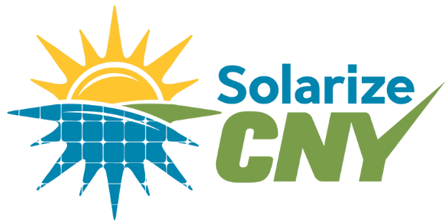
a grassroots, not for profit campaign
providing everything you need to know
about going solar

Sponsor SolarizeCNY
  - Promote renewable energy, Fight climate change, Support your community
SolarizeCNY is a grassroots, community based effort to help residents throughout the five county region of Central New York to take collective action to reduce the use of non-renewable energy sources, and shift our region to clean, sustainable energy sources. We invite you to join us in this effort. By joining this campaign, you can help dramatically increase the adoption of solar energy in our area!
Our program helps residents go solar by educating them on how solar works, how to take advantage of tax credits and incentives, and how to choose an installer. Our goal is to double the amount of solar energy in our region by 2020, and we need people like you to help make it happen.
  - How We’re Going to Do It
- Provide education to customers on rooftop solar AND new community solar, which is coming soon.
- Partner with seven solar installers from our region to provide a variety of options for customers. These installers went through a vetting process to determine that they were the best qualified.
- Create partnerships with organizations and businesses in the community, to help spread the word on renewable energy options.

SolarizeCNY is currently ramping up our 2016/2017 campaign. We invite your organization to become a co-sponsor of the SolarizeCNY campaign. Join us in collective action to reduce Central New York’s contribution to climate change, build a local, renewable economy, and to promote renewable energy in our communities.
This is the kind of campaign that only thrives when the community comes together to participate and helps make it happen. So, let’s make solar happen in CNY!
Ready to sign up to be a co-sponsor? It’s easy. Just fill out the form and return it to the address, both located on the back of this page!
SolarizeCNY is modeled after other successful Solarize initiatives that have already taken place in our area, including campaigns in Tompkins’ County, Madison County, and Syracuse. It’s a proven method that works when we all work together. Join us in collective action to reduce Central New York’s contribution to climate change, build a local, renewable economy, and to promote renewable energy in our communities.
For more information, contact Katelyn Kriesel, the SolarizeCNY Project Coordinator at 315-422-8224 or kkriesel@cnyrpdb.org.

SolarizeCNY Sponsorship Form

Organization Name: _________________________________________________________________________
Contact Person: ____________________________________________________________________________
Email Address: ___________________________________ Phone Number: _____________________________

Address: __________________________________________________________________________________
Action Items: (Please choose at least 4 Items from any category)

Contribute:

- $50.00 $100.00 $250.00 $500.00 $__________
- Donate resources, such as in house printing, materials, refreshments, staff time

Promote:
- Write a letter to your local newspaper
- Publish in your newsletter
- Add event to your website or public calendar
- Hang flyers in your building/ store, or around the community
- Put out a lawn sign, or help distribute lawn signs

Invite:
- On Facebook, invite friends to attend events, share our posts to your page or community group page
- Forward events and solarize emails to your email list
- Invite friends and colleagues to attend events, become a volunteer, or become a cosponsor

Educate:
- Host a Lunch and Learn, workshop or solar fair!

If there are other ways that you would like to assist our campaign, and help spread the word on renewable energy in our region, please let us know here!

Signature_______________________________________________________ Date: _____________________
Please return form to SolarizeCNY, c/o the Central New York Regional Planning and Development Board,
126 N. Salina Street, Suite 200, Syracuse, NY 13202. Checks can be made out to the Central New York Regional Planning and Development Board

